COMHAIRLE CHONTAE LONGFOIRT

*Longford County Council*

Corporate Affairs,

Aras an Chontae,

**LONGFOIRT.**

**7th November 2014.**

**Chuig: Gach Ball don Chomhairle.**

**A Chomhairleoir,**

You are requested to attend the Statutory Local Authority Budget Meeting of Longford County Council to be held in the Council Chamber, Aras an Chontae, Longford, on **Tuesday, 18th November 2014** **at 4.00 p.m*.*** to transact business as set out on the agenda hereunder.

**Mise le meas,**

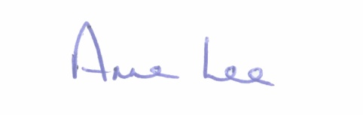

________________

**Anne Lee,**

**Meetings Administrator.**

**1**. Consideration of Draft Budget 2015 - Draft Budget enclosed

**2.** Consideration of Report on Capital Programme **-** Report enclosed.

**:::::::::::::::::::::::::::::::**